Lab 10
Interfacing an external LCD to the MSP430 Microcontroller and Onboard LCD


Spring 2025

Submitted by: Naveed Ahmad
Registration No: 22pwsce2165
Class Section: B

“On my honor, as student of University of Engineering and Technology, I have neither given nor received unauthorized assistance on this academic work.”

Student Signature: ______________

Submitted to:
Engr. Faheem Jan
Month Day, Year (02,06, 2025)

Department of Computer Systems Engineering
University of Engineering and Technology, Peshawar

Interfacing an external LCD to the MSP430 Microcontroller and Onboard LCD
TASKS:
1) Write Your Name on First Line and registration Number on second line of LCD (use proteus or attach external LCD with MSP).
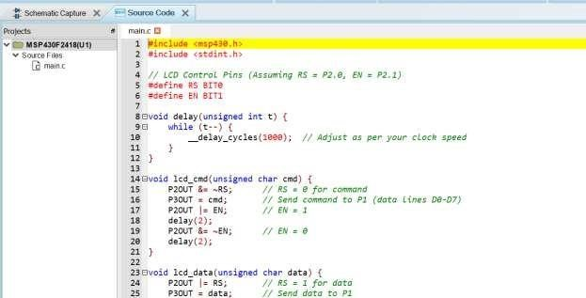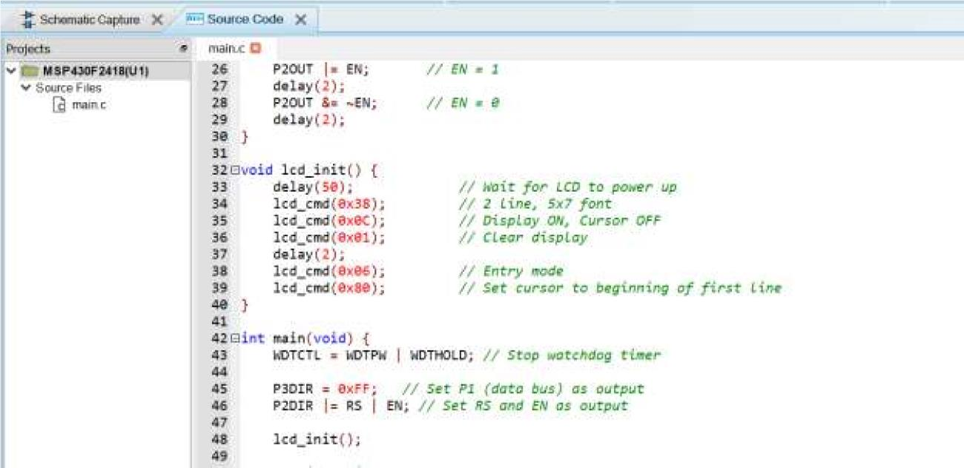

CODE:

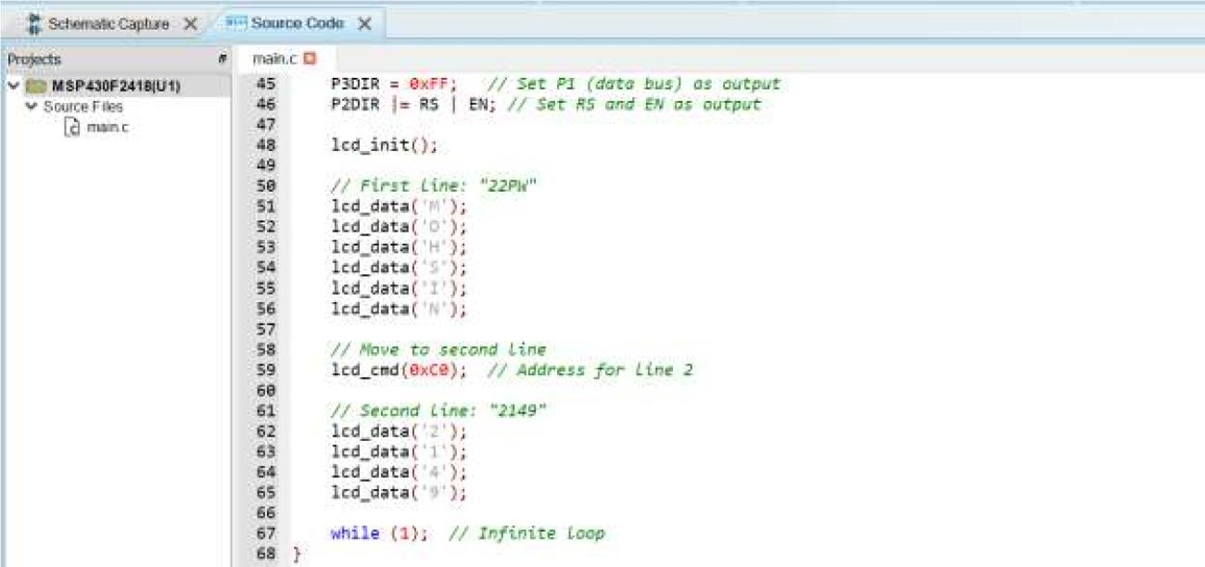
OUTPUT:
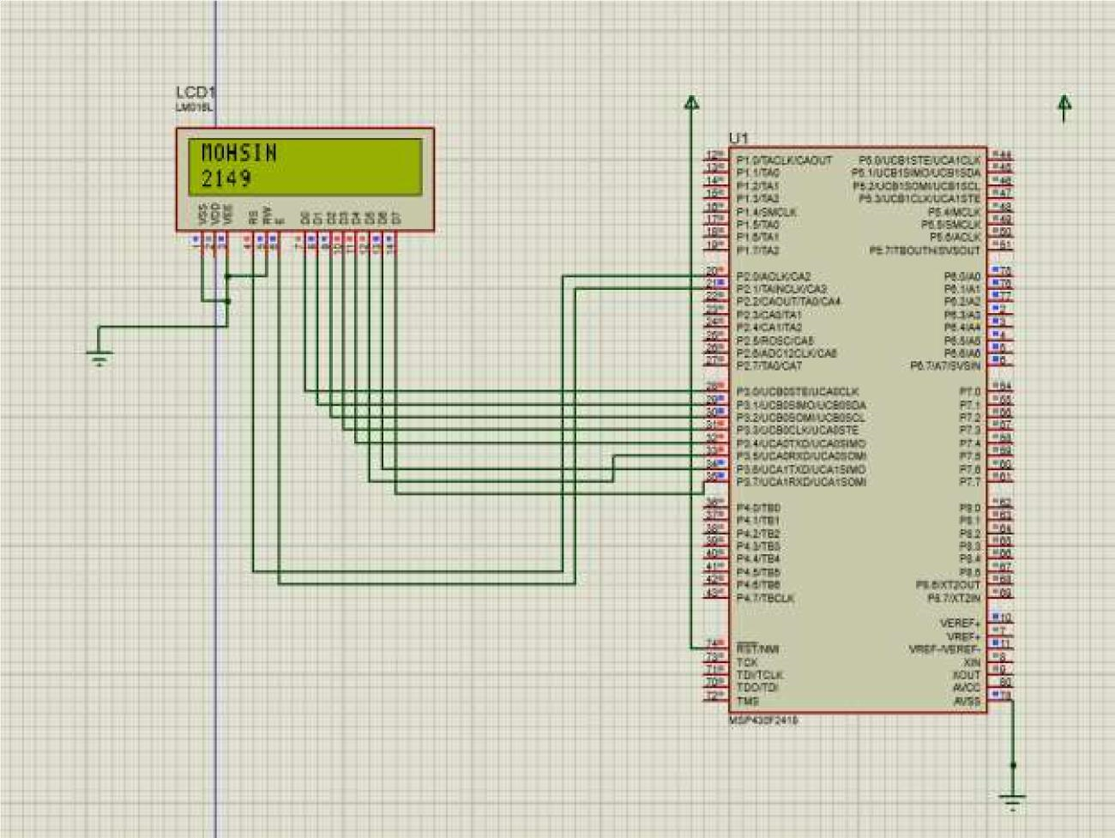

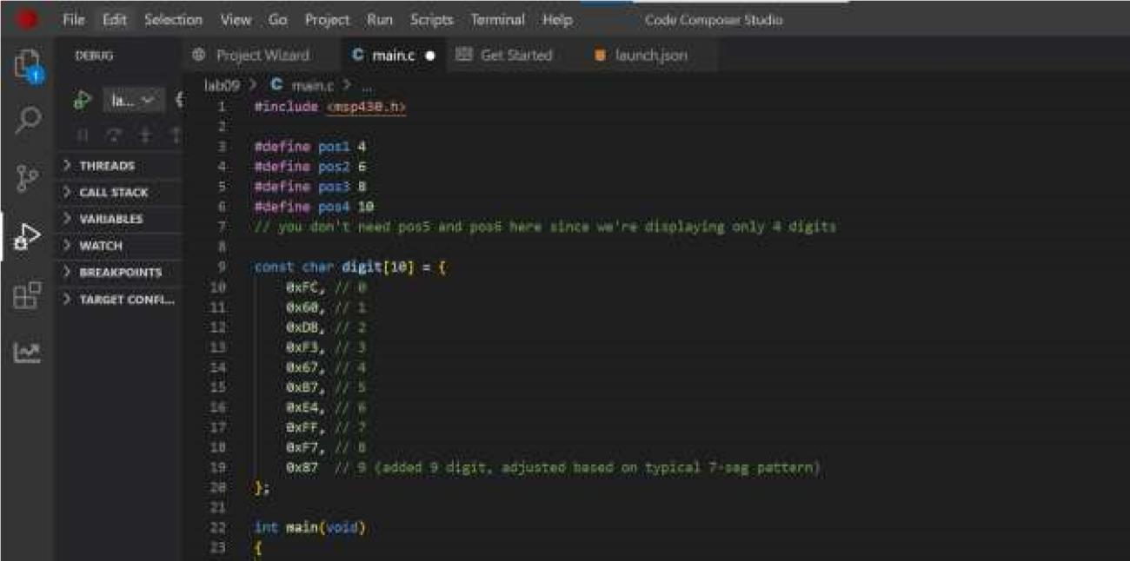
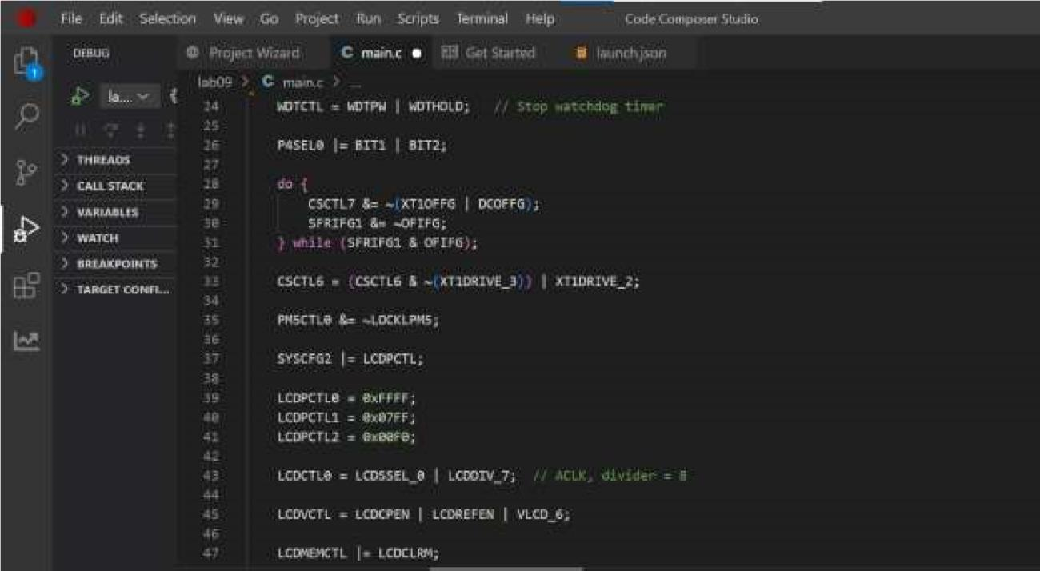
Task 2:

Write last four digit of your registration Number On the Onboard LCD of msp430fr4133.

CODE:
